**MODULE 3 – AWS Networking**

This module will cover the details around Amazon VPC and its components & is also more geared towards Amazon EC2 activity.

**Networking:**

AWS Global Infrastructure is a good example where AWS has built a network of resources using data centers, Availability Zones, and Regions.

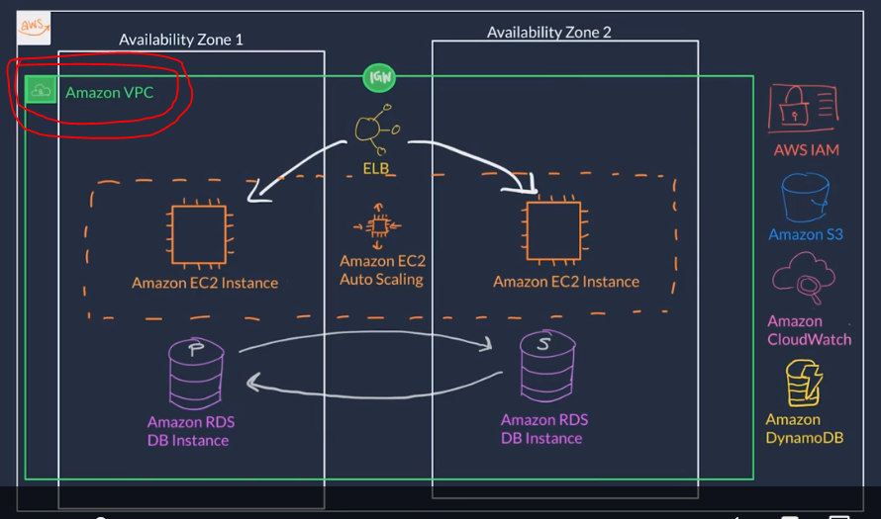

**Classless Inter-Domain Routing (CIDR)**: It’s a compress notation to specify a range of IP addresses.

For example, 192.168.1.0/24; the number 24 at the end specifies how many bits of the IP address are fixed. In this case, the first 24 bits of the IP address are fixed. The rest is flexible.

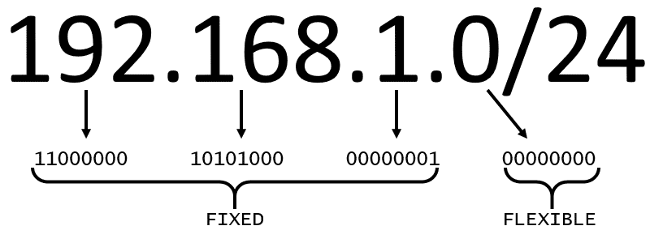

* 32 total bits subtracted by 24 fixed bits leaves 8 flexible bits.
* Each of these flexible bits can be either 0 or 1, because they are binary.
* That means that you have two choices for each of the 8 bits, providing 256 IP addresses in that IP range. (*32 total bits multiplied by 8 flexible bits*).
* The higher the number after the /, the smaller the number of IP addresses in your network. For example, a range of 192.168.1.0/24 is smaller than 192.168.1.0/16.
* In AWS, the smallest IP range you can have is /28, which provides 16 IP addresses. The largest IP range you can have is /16, which provides 65,536 IP addresses.

**Amazon Virtual Private Cloud:**

A **virtual private cloud** (VPC) is an isolated network that you create in the AWS Cloud, similar to a traditional network in a data center.

When creating a VPC, you need to declare 3 specific settings;

* **Name** of the VPC.
* **Region** where the VPC will live. Each VPC spans multiple Availability Zones within the selected Region.
* **IP range for the VPC in CIDR notation**. This determines the size of your network. Each VPC can have up to four /16 IP range.

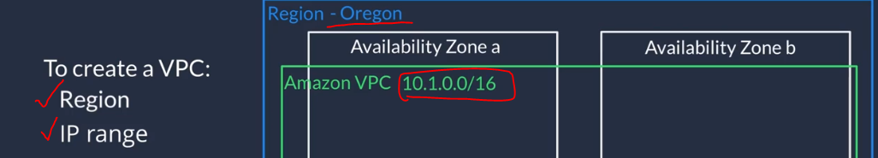

Creating a VPC in AWS Management Console:

1. First we need to make sure that the “Region” is selected correctly.

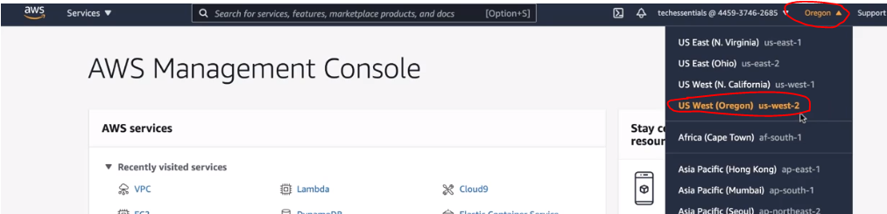

1. Then navigate to VPC dashboard and hit “Create VPC”.

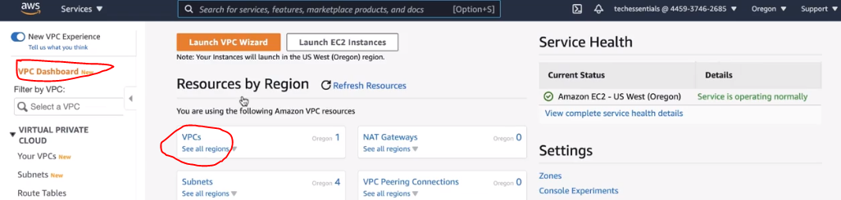

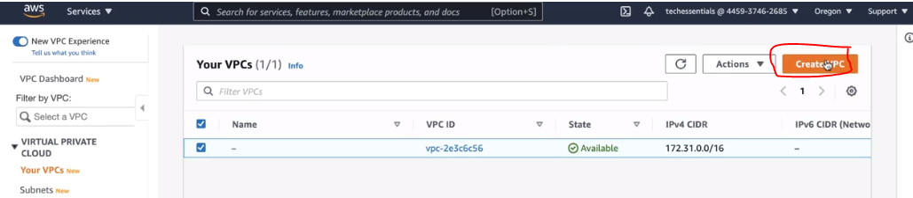

1. In the create VPC page, we need to configure few settings and leave the rest as default.

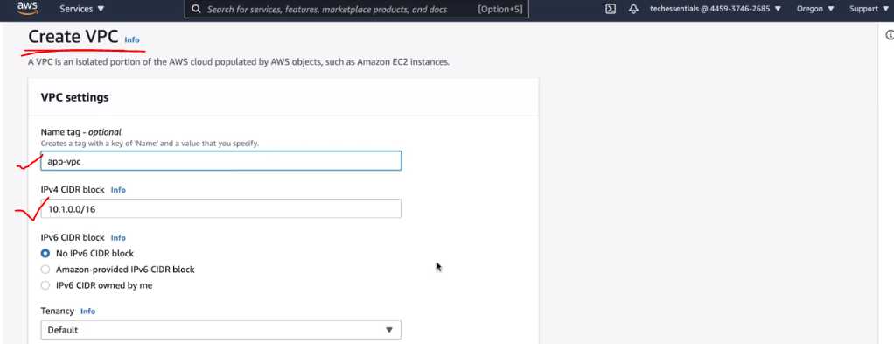

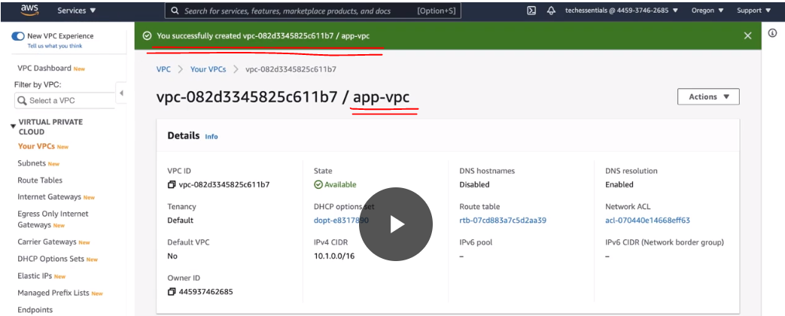

**Create a subnet**:

We need to create subnet inside our VPC which will act as smaller network inside our base network or virtual local area networks (VLANs) in a traditional, on-premises network.

In AWS, subnets are used to provide high availability and connectivity options for your resources.

When you create a subnet, you must specify the following:

* **VPC** you want your subnet to live in. In this case: VPC (10.0.0.0/16)
* **Availability Zone** you want your subnet to live in. In this case: AZ1
* **CIDR block for your subnet**, which must be a subset of the VPC CIDR block. In this case: 10.0.0.0/24

When you launch an EC2 instance, you launch it inside a subnet, which will be located inside the Availability Zone you choose.

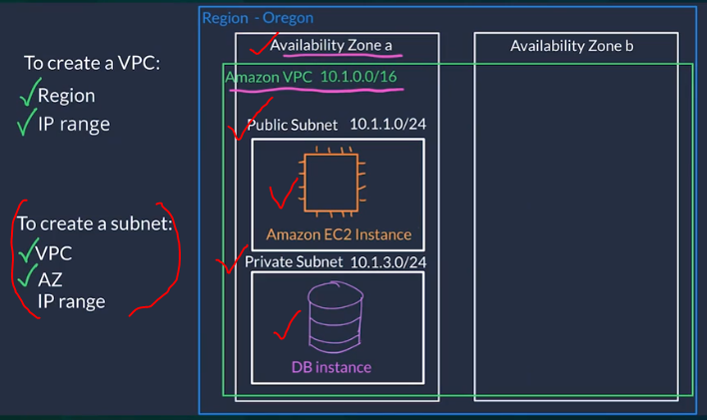

For our exercise, we shall create a **Public Subnet (10.1.1.0/24) hosting our Amazon EC2 Instance** which will be interacting with the public internet domain and a **Private Subnet (10.1.3.0/24) hosting our DB Instance** which stores our private data and is off-limits for the public internet domain access.

1. In the VPC dashboard, click on “Subnets” and hit “Create Subnet”

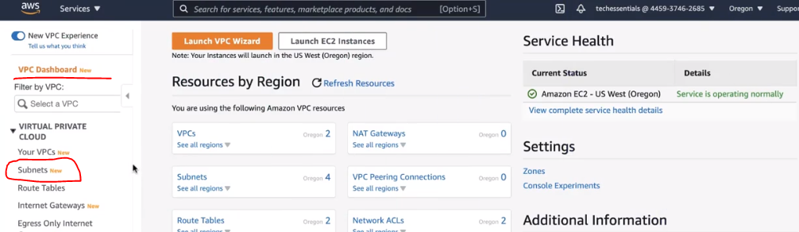

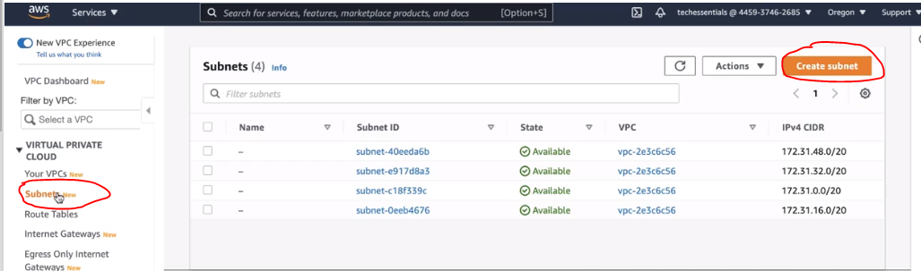

1. Select the VPC that we just created and fill in the other details like Subnet name, Availability Zone and IP address of the subnet. Similarly, repeat the operation for Private Subnet as well.

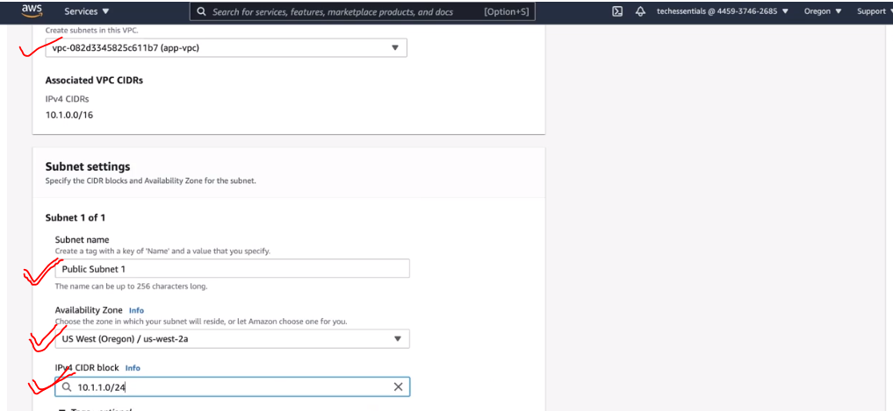

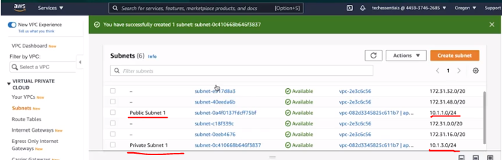

**High availability with a VPC**:

To maintain redundancy and fault tolerance, create at least two subnets configured in two Availability Zones.

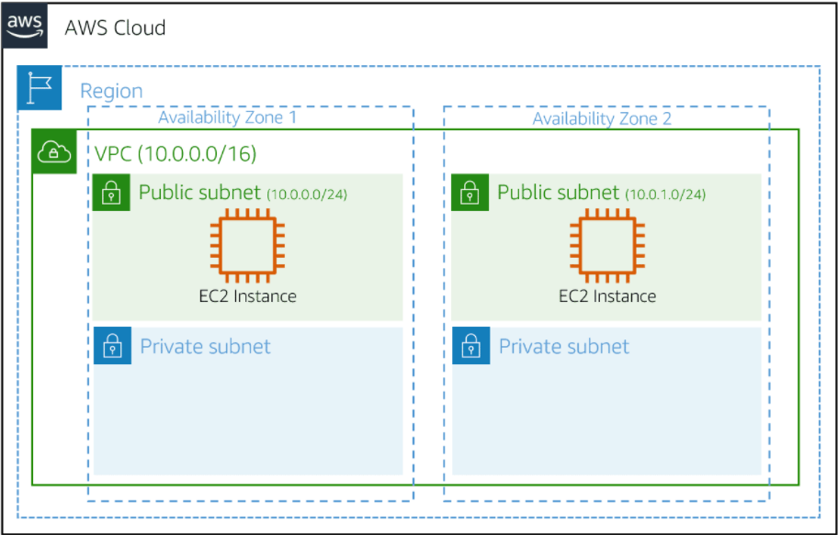

**Reserved IPs:**

For AWS to configure your VPC appropriately, AWS reserves five IP addresses in each subnet. These IP addresses are used for Routing, Domain Name System (DNS), and network management.

For example, consider a VPC with the IP range 10.0.0.0/22. The VPC includes 1,024 total IP addresses. This is divided into four equal-sized subnets, each with a /24 IP range with 256 IP addresses. Out of each of those IP ranges, there are only 251 IP addresses that can be used because AWS reserves five.

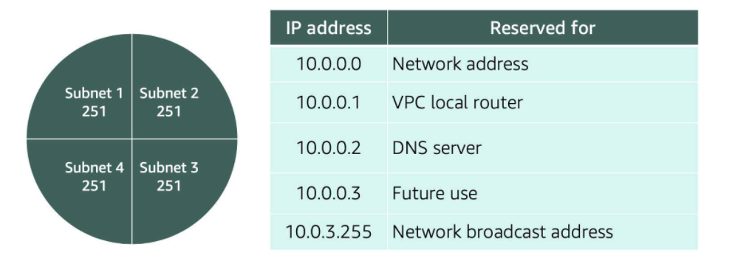

A common starting place for those who are new to the cloud is to create a VPC with an IP range of /16 and create subnets with an IP range of /24. This provides a large amount of IP addresses to work with at both the VPC and subnet levels.

**Gateways – Internet Gateway (IGW)**

Just as a modem connects your computer to the internet, the internet gateway connects your VPC to the internet. After you create an internet gateway, you need to attach it to your VPC.

1. Navigate to the “Internet Gateway” screen and hit “Create Internet gateway”

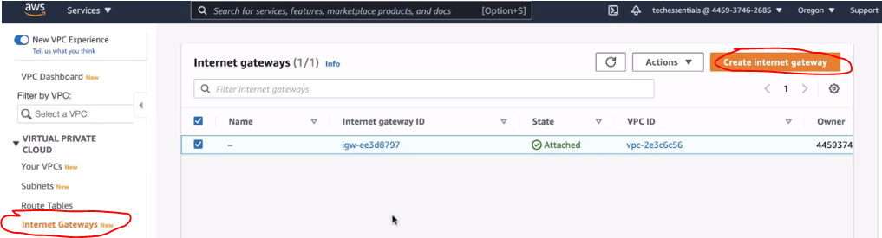

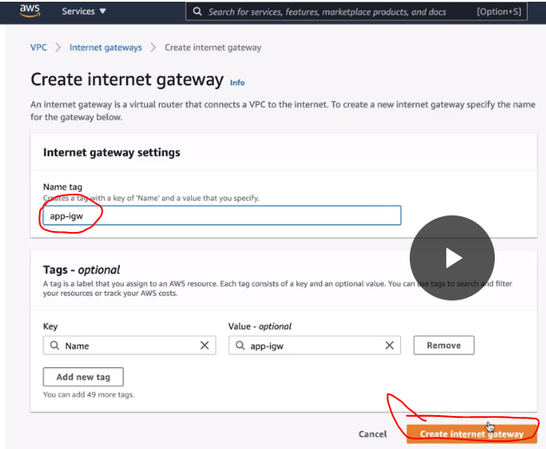

1. On the details page, select the “Attach VPC” under Actions and choose our VPC we created earlier.

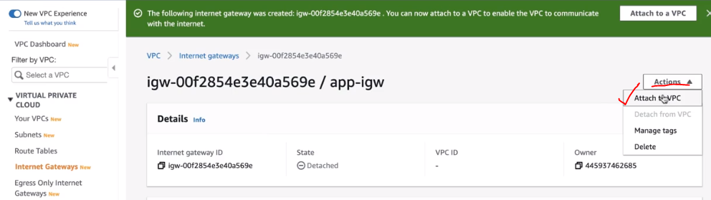

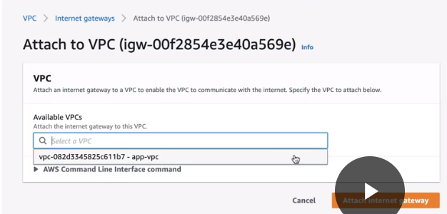

**Gateways – Virtual Private Gateway (VGW)**

A virtual private gateway connects your AWS VPC to another private network.

* Once you create and attach a virtual private gateway to a VPC, the gateway acts as anchor on the AWS side of the connection.
* On the other side of the connection, you will need to connect a customer gateway to the other private network.
* A customer gateway device is a physical device or software application on your side of the connection.
* Once you have both gateways, you can then establish an encrypted VPN connection between the two sides.

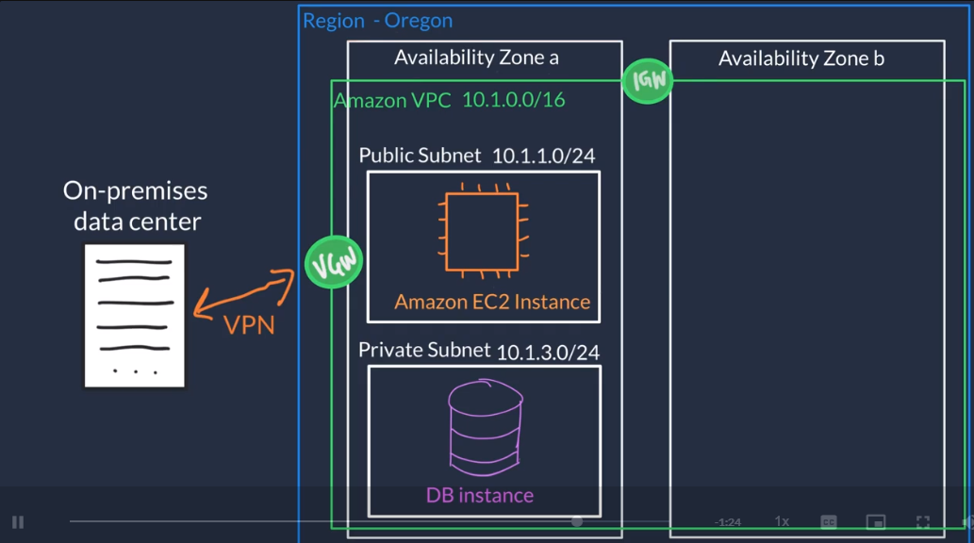

**Amazon VPC Routing:**

**Route Table** is used to provide the correct path for the network traffic to reach to the correct subnet in a VPC via IGW.

* Route tables contain set of rules called routes that is used to determine where the network traffic is directed.
* Routes can be applied either at the subnet level or at the VPC level.
* When you a create a new VPC, AWS creates a route table named “Main route table” by default and attaches it to the entire VPC.

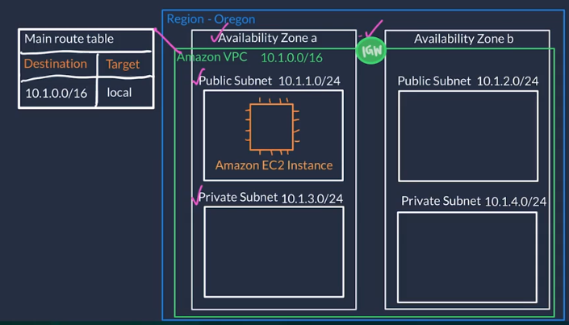

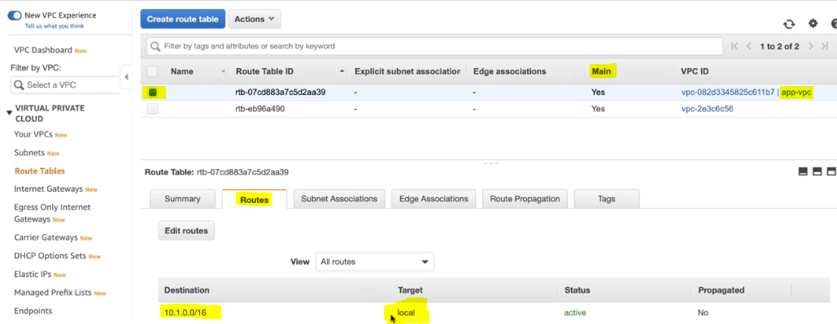

This main route table has the destination of the VPC IP address that means all the components local (*Private and Public Subnet we created earlier*) to the VPC can interact with each other.

**Custom Route Table** will have the default local route which allows the network traffic to flow freely within the VPC. We would need an additional route to make the public internet traffic flow between IGW and Amazon EC2 instance located in the public subnet.

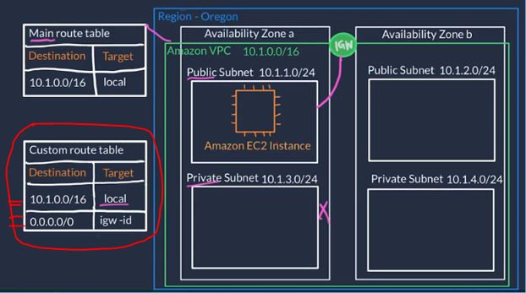

1. Create a custom route table for connecting the IGW with public subnet in the VPC so that the customer can access the employee directory from the internet. **Each custom route table you create will have the local route already inside it, allowing communication to flow between all resources and subnets inside the VPC. The local route cannot be deleted**.

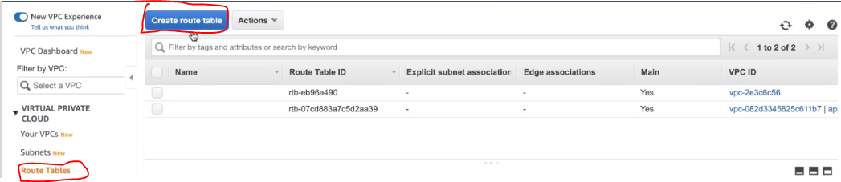

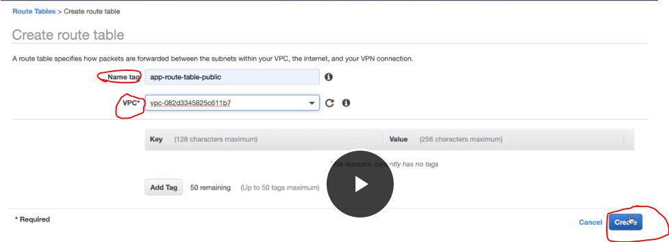

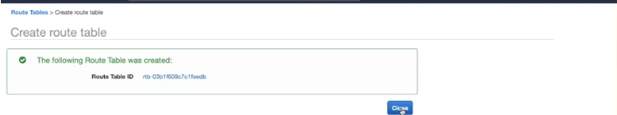

1. After creating the custom route table, we need to connect it to the internet gateway that was created earlier for the public internet traffic to flow in.

Add a new route with destination as “0.0.0.0/0” which means it will allow the all network traffic and then choose the IGW that we created earlier.

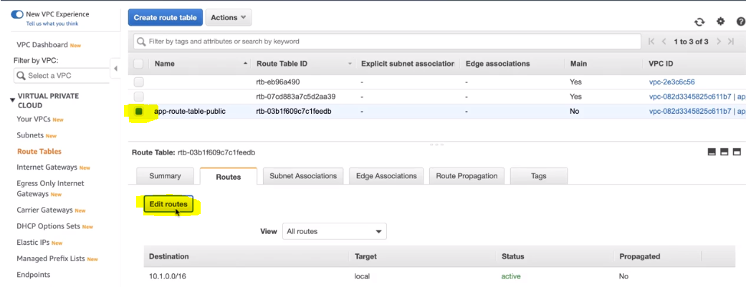

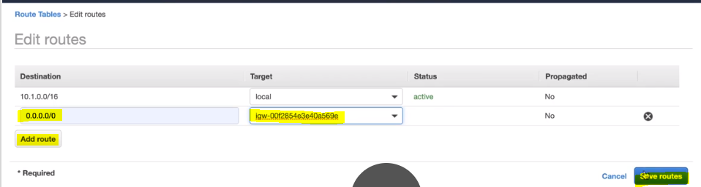

1. Now, that we have created a custom route table and connected with IGW, we need to connect the route table to the 2 public subnets in our AZ-a and AZ-b so that the internet traffic is allowed to connect with public subnets via IGW.

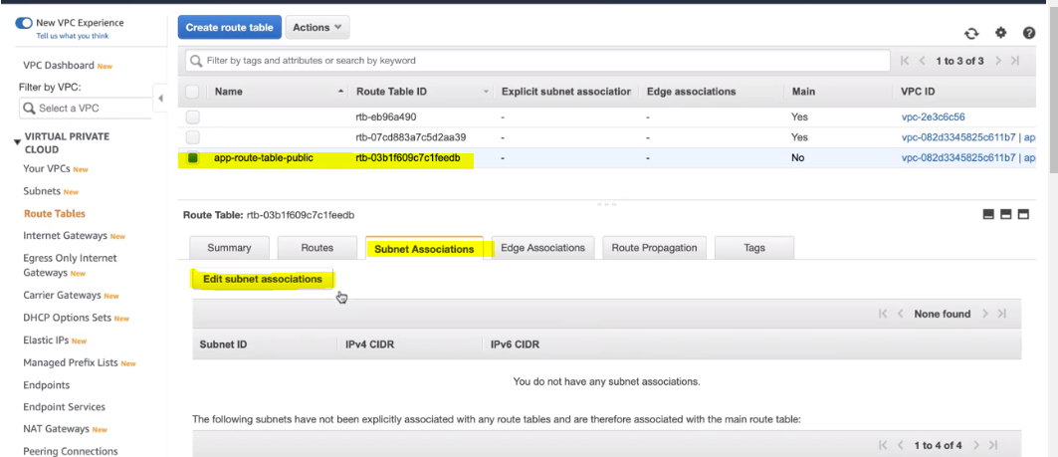

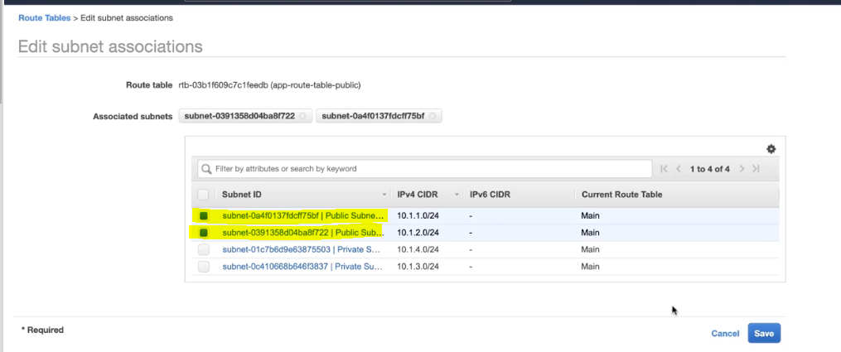

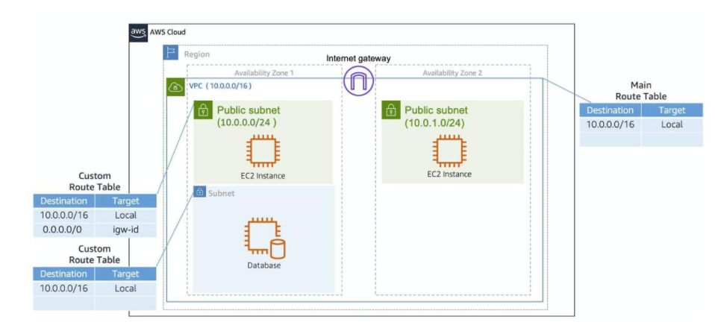

**Amazon VPC Security:**

In AWS, you have two options to secure your VPC resources when its open for public internet traffic via IGW.

1. **Network Access Control Lists (Network ACLs)** -

* This is a firewall at the subnet level.
* This can help control the type of network traffic entering and exiting from the subnet.
* A network ACL will be created by default around a newly created subnet (***the pink colored boxes***) and by default it will allow all the network traffic to reach and exit the VPC.

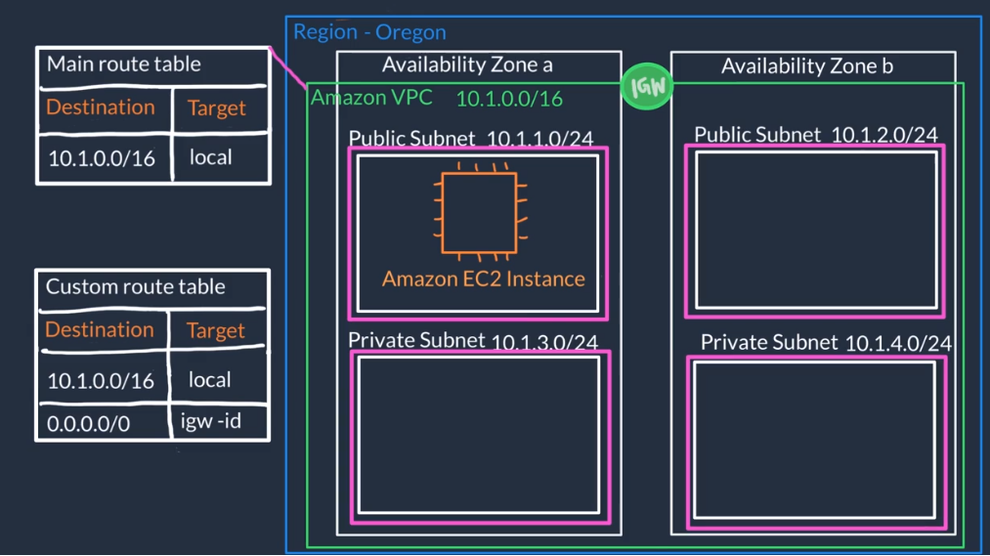

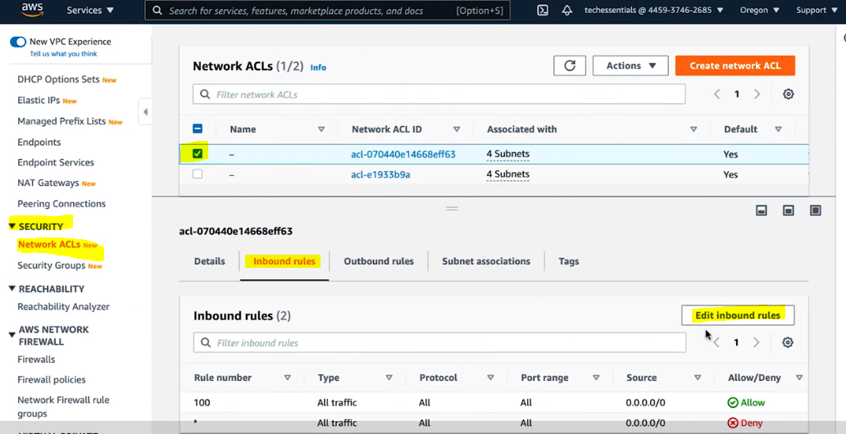

Here, we will set the HTTPS (443) as the only traffic type which will be allowed to reach the VPC and leave the VPC as part of Inbound Rules and Outbound Rules as per the snippet shown below.

* Network ACLs are considered stateless, so you need to include both the inbound and outbound ports used for the protocol.

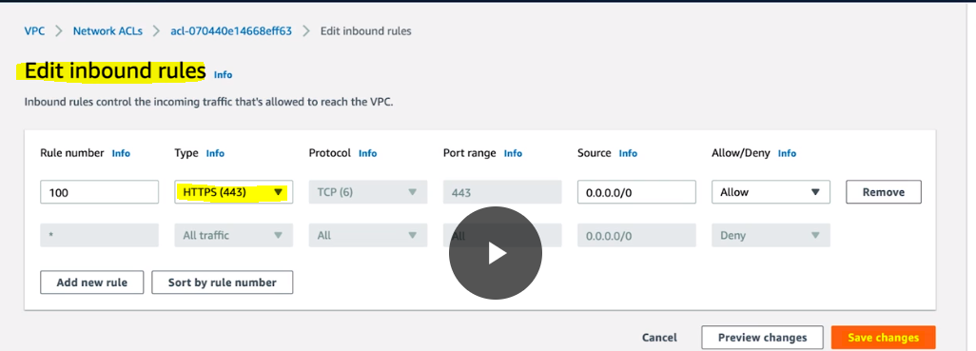

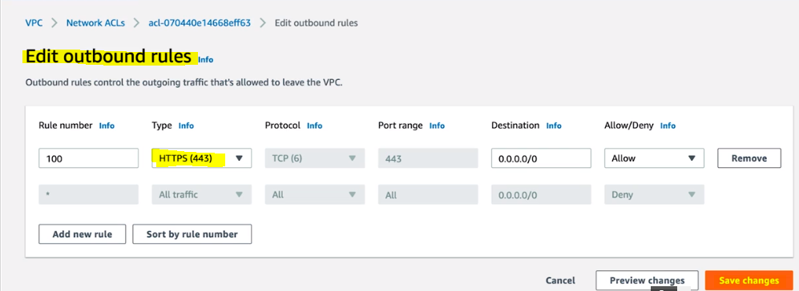

1. **Security Groups** -

* This is a firewall at the Amazon EC2 level and everything is blocked by default.
* These are NOT optional and anytime a new EC2 is created we need to place it under a security group which will allow appropriate traffic to flow to your application (*circled in red*).

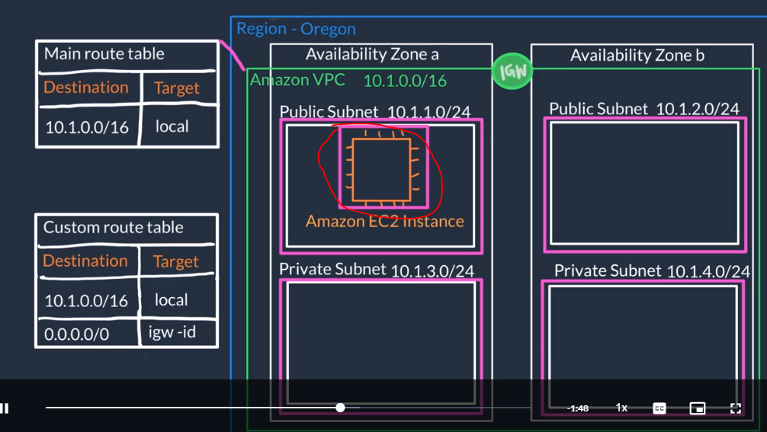

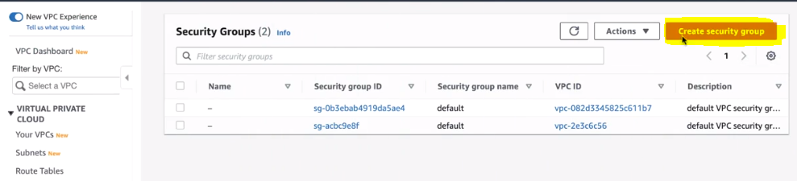

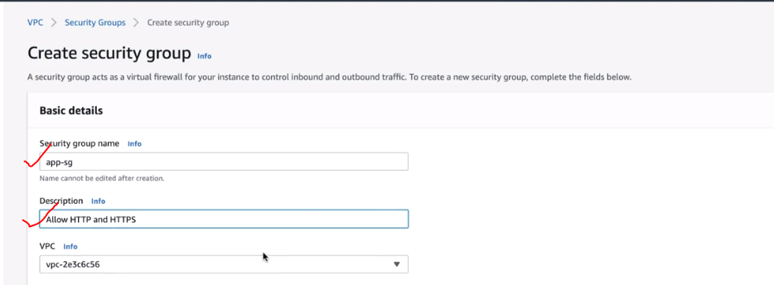

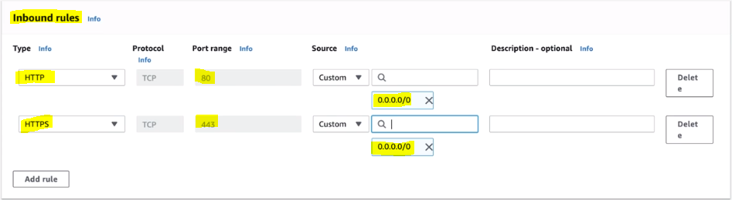

**No changes to “Outbound rules” setup will be required.**

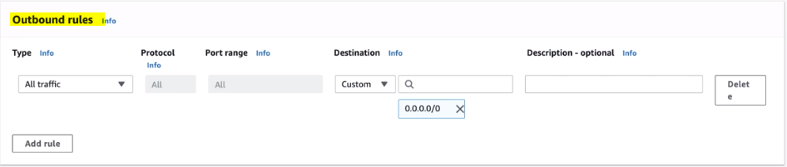

**In case of Network ACL’s**, all traffic is allowed by default but we can control using both “Allow” and “Deny” rules.

**In case of Security Groups**, by default blocks all inbound traffic and allows all outbound traffic but we can control using “Allow” rules only.

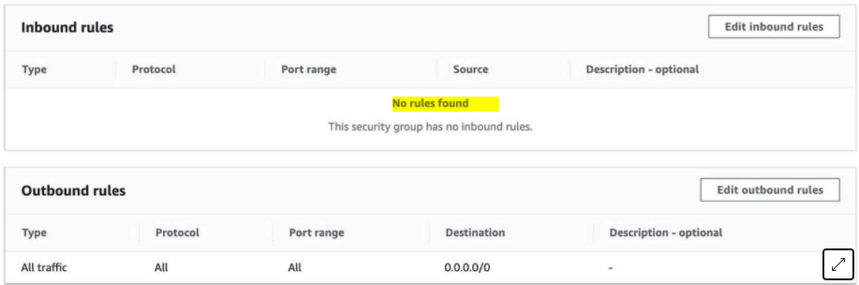

You might be wondering, “Wouldn’t this block all EC2 instances from receiving the response of any customer requests?” Well, **security groups are stateful**. That means that they will remember if a connection is originally initiated by the EC2 instance or from the outside, and temporarily allow traffic to respond without modifying the inbound rules.

Segregate traffic between different components in a AZ:

* Internet traffic to the Web Tier is allowed over HTTPS,
* Web Tier to Application Tier traffic is allowed over HTTP, and
* Application tier to Database tier traffic is allowed over TCP (MySQL)

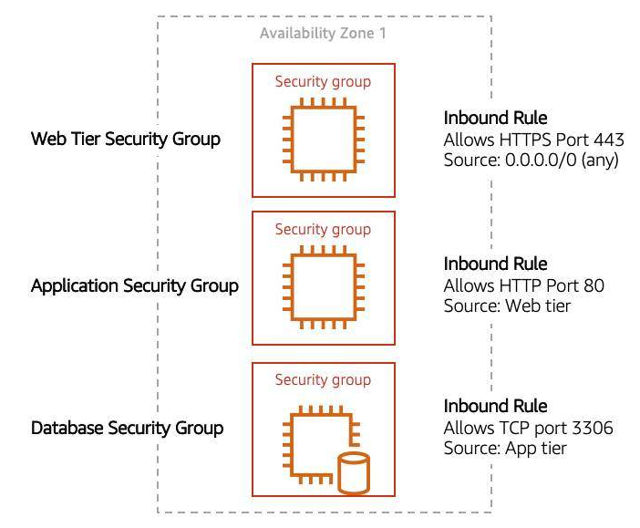

**Demonstration: Create a VPC and Relaunch the Corporate Directory Application in Amazon EC2**

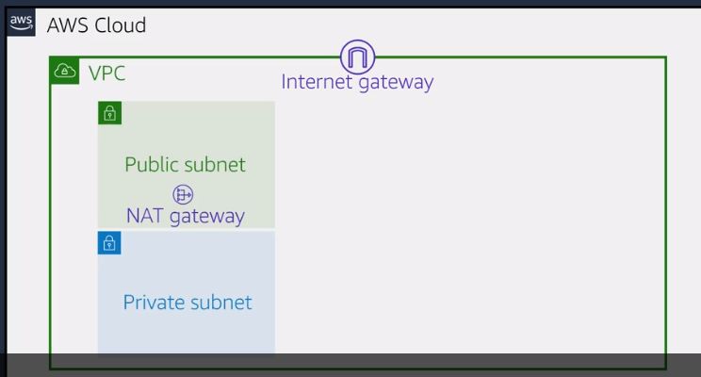

1. Create an Elastic IP address for the EC2 instance.

Sign in as IAM user (getrpd-admin) => go to EC2 => then under “Network & Security” click “Elastic IPs”.

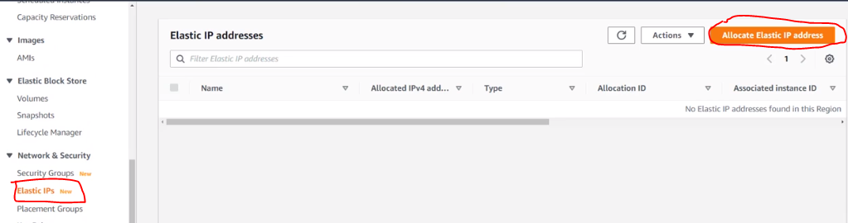

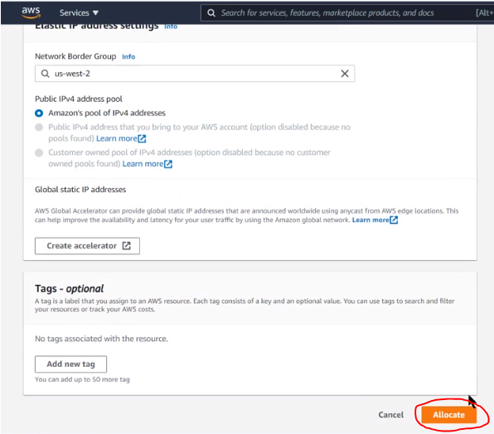

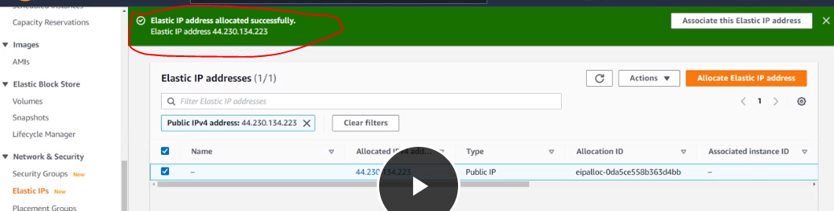

1. Launch VPC wizard.

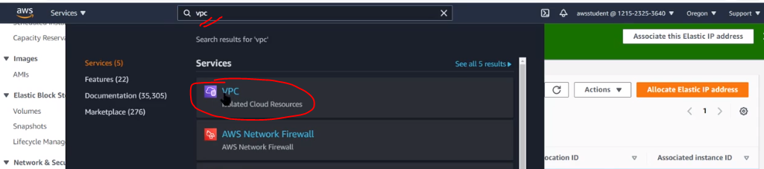

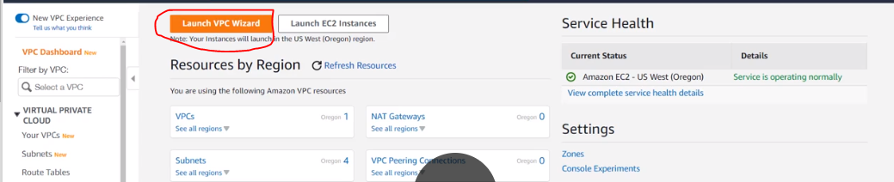

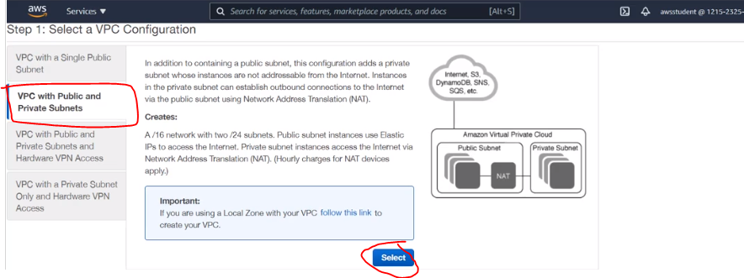

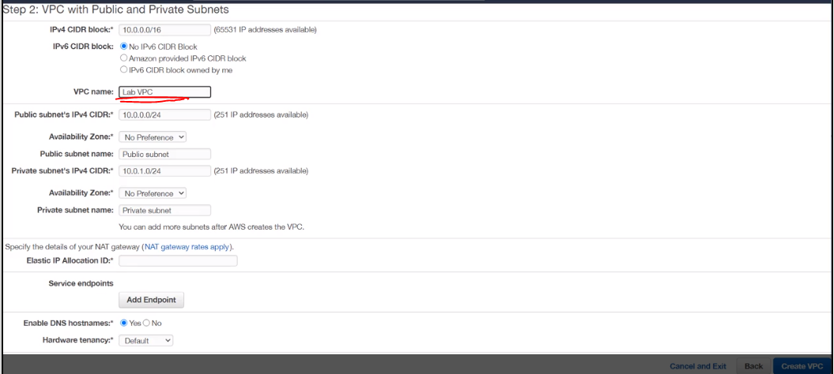

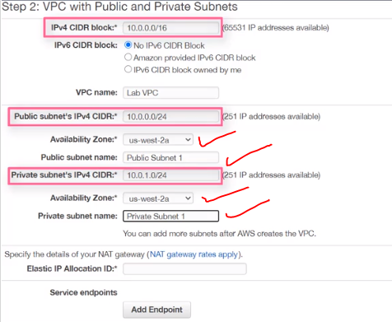

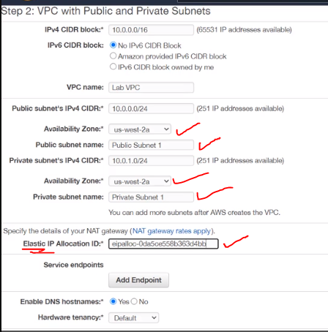

We make the VPC to take advantage of the public and private subnets in both AZ’s.

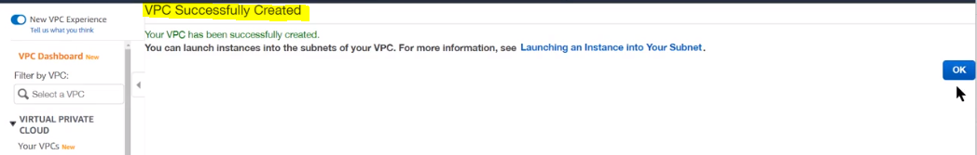

1. Creating new subnets in AZ-b for high availability

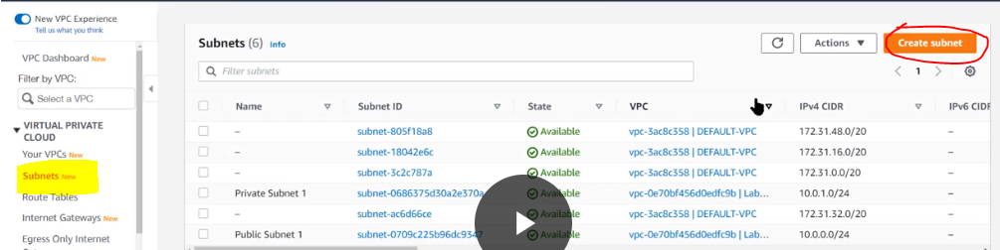

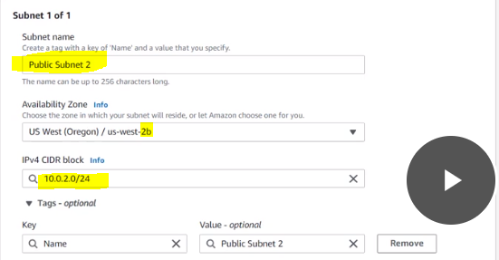

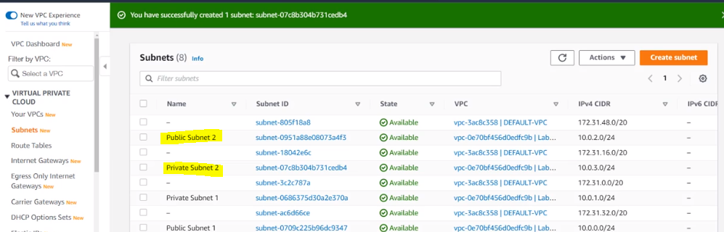

1. Now, we will create the routing tables to make sure that the resources in the public subnets will use the IGW gateway and the resources in the private subnet use the NAT gateway.

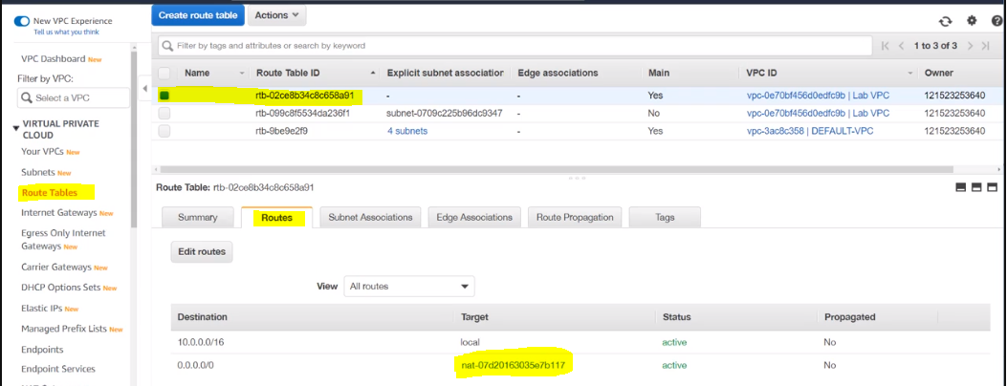

1. Here, we will rename the selected route table and give a relevant name as “Private Subnet Route” and also, associate the private subnets to this route table.

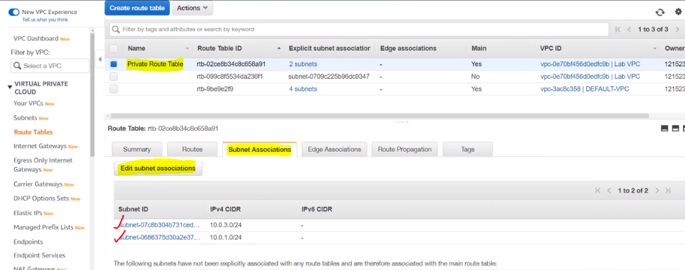

1. Perform the same steps for Public Route and subnet associations.

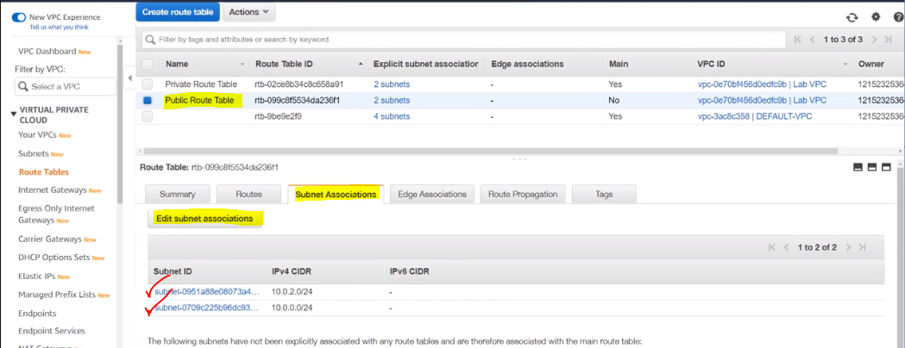

**Summary of the steps so far:**

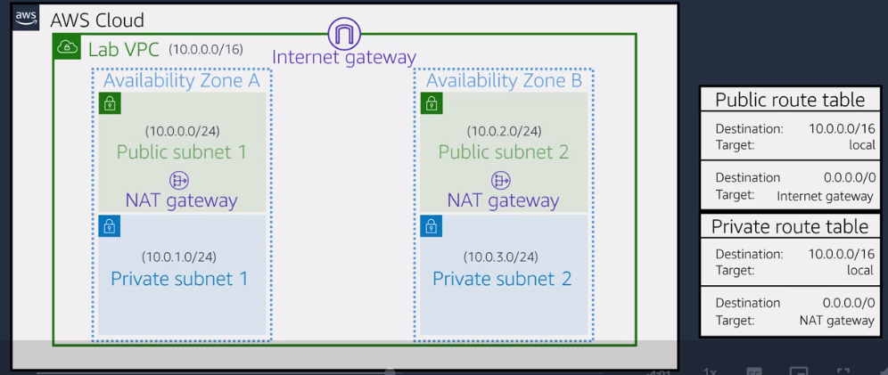

1. Now, let’s get really granular with the traffic network control by adding a “Security Group”. And for this demo, we would only need web access.

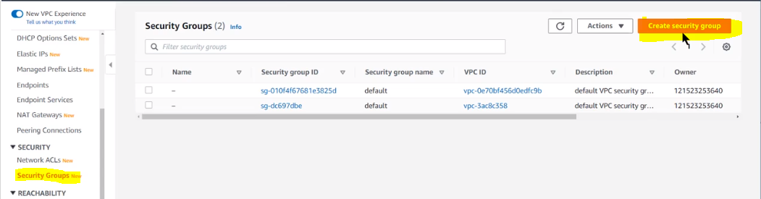

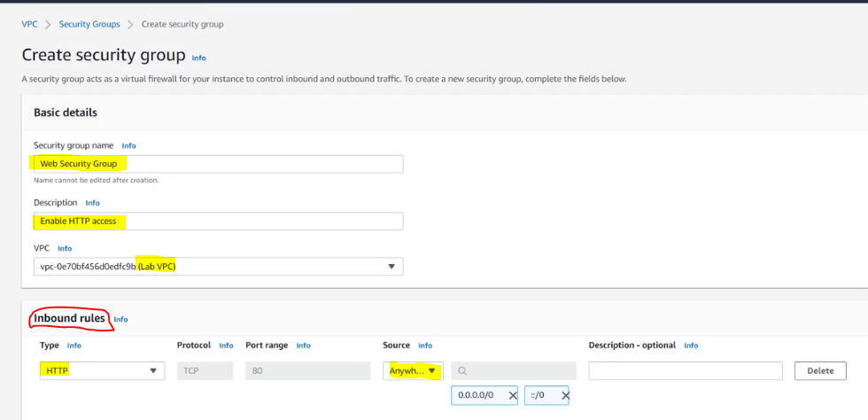

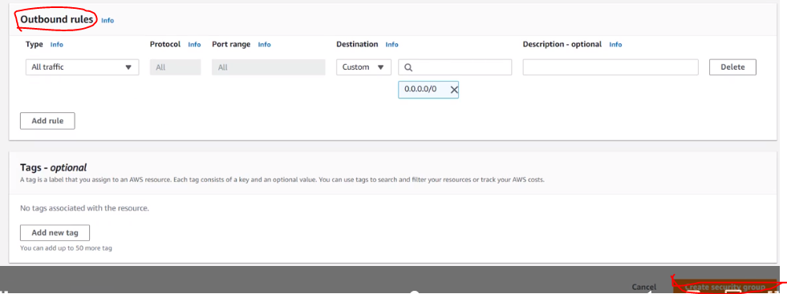

1. Finally, all out steps are complete.

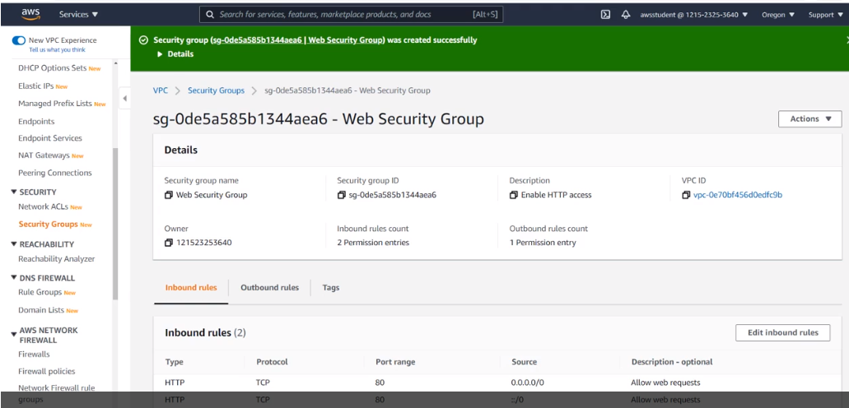

1. Now, to test the application readiness by traversing to Amazon EC2 instance and launching it.

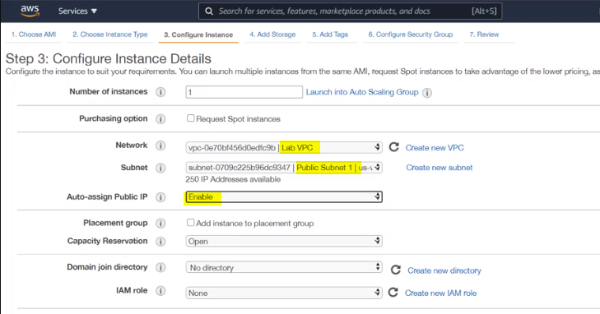

**The steps in “User Data” will load and install our web application when the instance launches.**

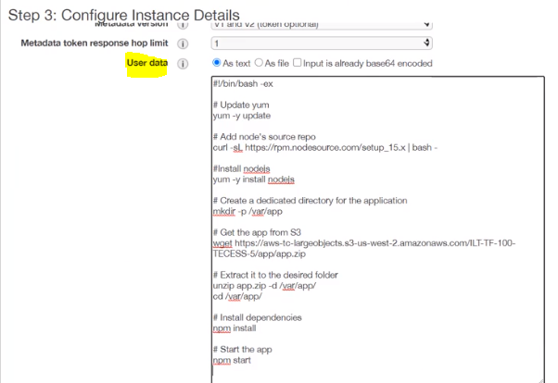

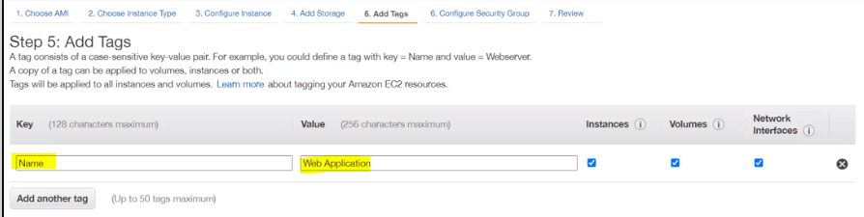

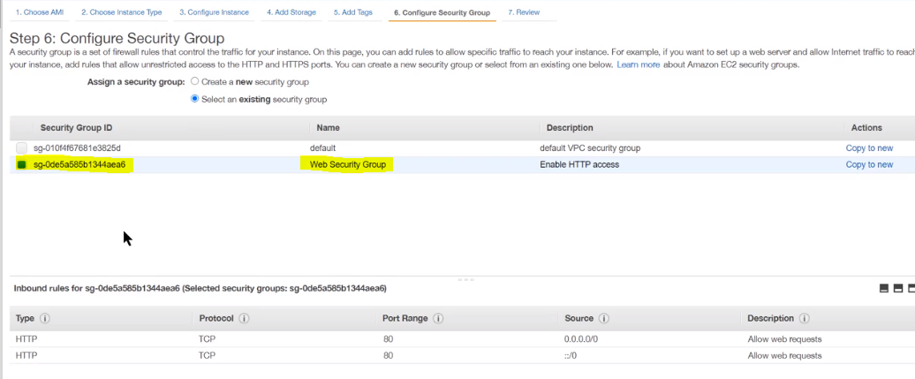

**Finally, Instance is up and running and we can test the web application.**

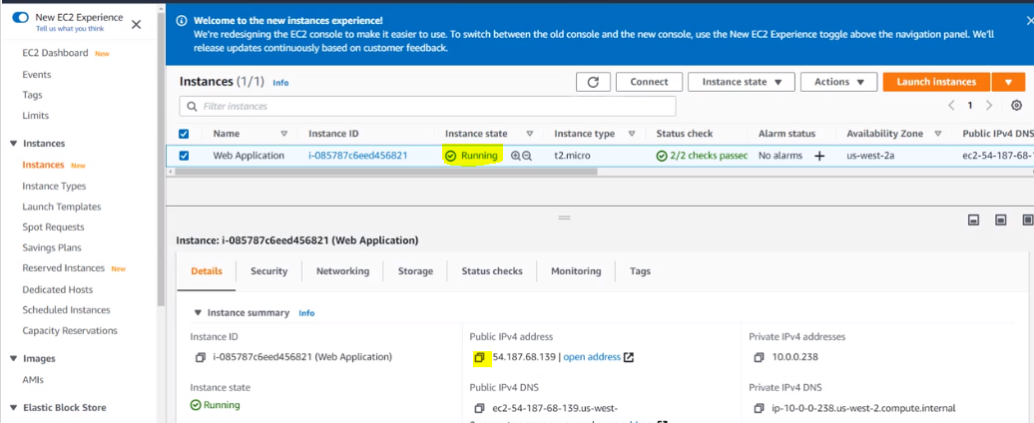

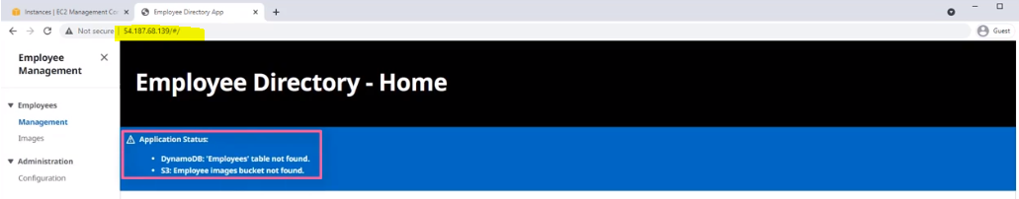

**Quiz:**

Which of the following pieces of information do you need to create a virtual private cloud (VPC)?

AWS Region it will reside in

Which of the following is true for a security group's default setting?

Blocks all inbound traffic and allows all outbound traffic